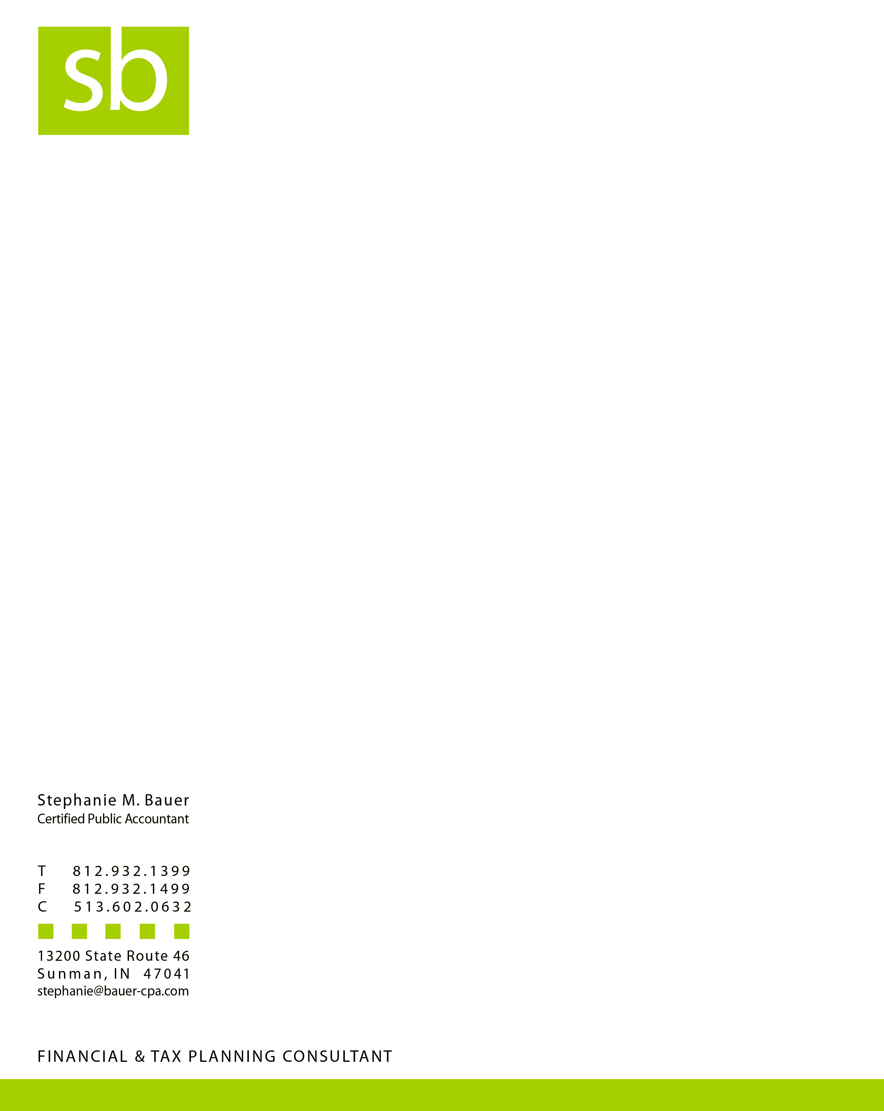

2024 Individual Federal and State Tax Return Questionnaire

**Reviewing & completing this checklist will greatly facilitate the preparation of your tax return(s).** Please **return this document** with your tax paperwork:

Please remember to submit the following most common income items:

* W-2 forms for wages
* 1099 Div forms for dividend income
* 1099 Int forms for interest income
* 1099 R or SSA forms for retirement income
* Gambling Income
* 1099 Misc for rent income or 1099 NEC for non-employee compensation
* Tax refund form 1099 G for last year’s refund
* Unemployment compensation
* Business income

Please remember to submit the following most common expenses to deduct (write amount in margin but I would also like to see the supporting document(s)):

* Real estate taxes
* Mortgage Interest (Form 1098) or interest expense paid on a financed RV
* Contributions, please provide substantiation – cash or non cash
* Business expenses (please provide detail)
* Gambling expenses
* If you, or your spouse, are full time educators, please inform me of your out-of-pocket expenses. There is a federal deduction and a $100 credit on the Indiana return for eligible teachers
* Student loan interest on higher education debt, please provide form
* HSA distribution or contribution made by you (not your employer)
* Tuition or fees for higher education, please provide Form 1098-T
* Excise tax portion on your personal vehicles (your car registration)
* Any other deduction information – provide detail
* Provide total contributions to a college 529 plan and the account #
* Indiana residents – provide amounts paid to InvestABLE accounts
* Indiana residents – provide residential rent paid in 2024 & landlord
* Indiana residents - if your full-time student is either homeschooled or in private school (grades K-12) please advise.
* Indiana residents – provide total paid to health care sharing ministries
* Ohio residents - provide a copy of your driver’s license if it renewed or if you are a new client to the firm.

Medical expenses (prescription drugs, doctors, dentists, eyewear, miles on vehicle, etc.) generally cannot be deducted unless you incur a lot of unreimbursed expenses. This deduction is dependent upon income & whether you itemize.

*2024 Standard deduction amount: Single $14,500 and MFJ $29,200

**2025 Standard deduction amount: Single $15,000 and MFJ $30,000

Individual Federal and State Tax Return Questionnaire, Page 2

Please answer the following questions by writing ‘yes’, ‘no’ or the requested information in the margin.

* Did you adopt any child(ren) in 2024? If so, provide name and SS#.
* Did your marital status change during 2024? If so, to what.
* Did your address change in 2024 or 2025? If so, please provide address and date it changed.

The prior year’s address will be used unless you tell me otherwise.

* **Can you** (not ‘will you’) be claimed as a dependent by another taxpayer?
* Do you have any children under age 24 with interest, dividends or gains of over $2,200?
* Are any of your dependents married?
* Were there any changes in dependents from the prior year? If yes, explain and if there is a new

dependent, provide name, date of birth and SS#.

* Amount of child care paid while you worked or looked for work?
* Did you sell any assets in 2024 (house, stocks, business ownership or stock club ownership)?
* Did you pay any estimated tax payments towards 2024 taxes on the due dates of April 15th

2024, June 15th 2024, Sept 15th, 2024 or January 15th 2025? If so, please write the amount paid

for federal and for state taxes.

* Did you make a large purchase in 2024 (car, boat, RV, etc.)? Provide sales tax paid on item.
* Did you take a distribution from your retirement funds? Please provide the 1099-R form.
* What state were you a resident of as of December 31st?
* If you are a part-year resident, please provide dates of residency for each state.
* What was your county of residence as of January 1, 2024?
* What was your spouse’s county of residence as of January 1, 2024, if applicable?
* What school district do you currently live in?
* Did you have foreign income, pay any foreign taxes, or file any foreign information reporting or tax return forms? Provide details.
* **At any time during the year, did you have a financial interest in, or signature authority over a financial account such as a bank or a securities account located in a foreign country?**

**Please notify me if you would like me to efile Form 114 for you.**

* Are you planning on contributing to a Roth IRA, deductible IRA or nondeductible IRA?
* What bank account do you want your refund to be deposited? Provide the name of

financial institution, account #, routing # and whether it is a checking or savings account.

* Did you install a new exterior door or window, AC unit, furnace, water heater or geothermal system (note: roofs do not qualify for an energy credit)?
* May I be authorized to speak to the IRS or state, on your behalf, in the event there are questions about your return?

|  |
| --- |
| * Did you or your spouse, if applicable, at any time during 2024, receive, sell, exchange or   otherwise acquire any financial interest in virtual currency? |
| * If you purchased insurance from the exchange (a.k.a. marketplace health insurance), the   premium assistance credit advanced to you during the year must be reconciled on your tax  return. **Please provide Federal Form 1095-A**.  If you started a new business & acquired a federal EIN that I do not know about, please advise. |

Please provide phone number(s) and the email address I may reach you most efficiently.

Please list any phone number or email address you no longer use.